23CSE111 OBJECT ORIENTED PROGRAMMING
S2 B.Tech CSE
Department of Computer Science and Engineering
Amrita School of Computing, Amritapuri Campus
CASE STUDY
PHASE – 2 (Design)
Architectural Modelling (CO2)

Group No : C16
Team Members :
Roll No | Student Name
AM.SC.U4CSE25224 | Jayanth Amanchy
AM.SC.U4CSE25216 | Abhilaash Gali
AM.SC.U4CSE25248 | Shantanu S Shenoy
AM.SC.U4CSE25240 | Hanumanth Krishna

- Problem Title : Online Voting System

STRUCTURAL DESIGN
- Class diagram (draw class diagram that shows different classes and their relationships. Use UML notations)
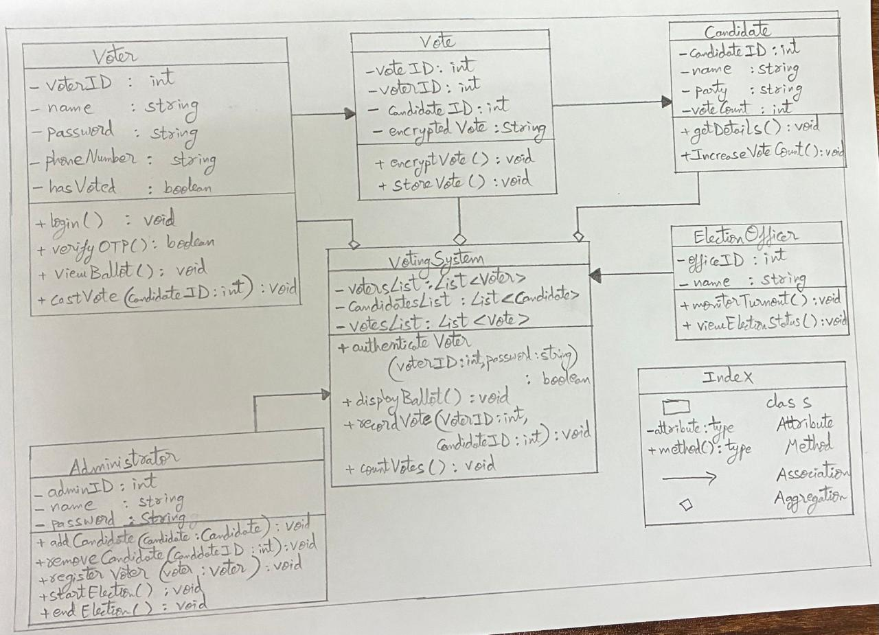

BEHAVIOURAL DESIGN
- Use-case diagram
- List of actors
- Voter
- Administrator
- Election Officer
- List of use-cases
- Voter Use Case:
Login: Voter enters credentials to access the system.
Verify OTP: Voter verifies identity using OTP.
View Ballot: System displays list of candidates.
Cast Vote: Voter selects a candidate and submits vote.

- Administrator Use Case:
• Add Candidate: Admin adds a new candidate to the system.
• Remove Candidate: Admin removes an existing candidate.
• Register Voter: Admin registers new voters.
• Start Election: Admin initiates the voting process.
• End Election: Admin terminates the voting process.
- Election Officer Use Case:
• Monitor Turnout: Observes voting participation.
• View Election Status: Checks current election progress/results.

- Use case diagram (use UML notations)
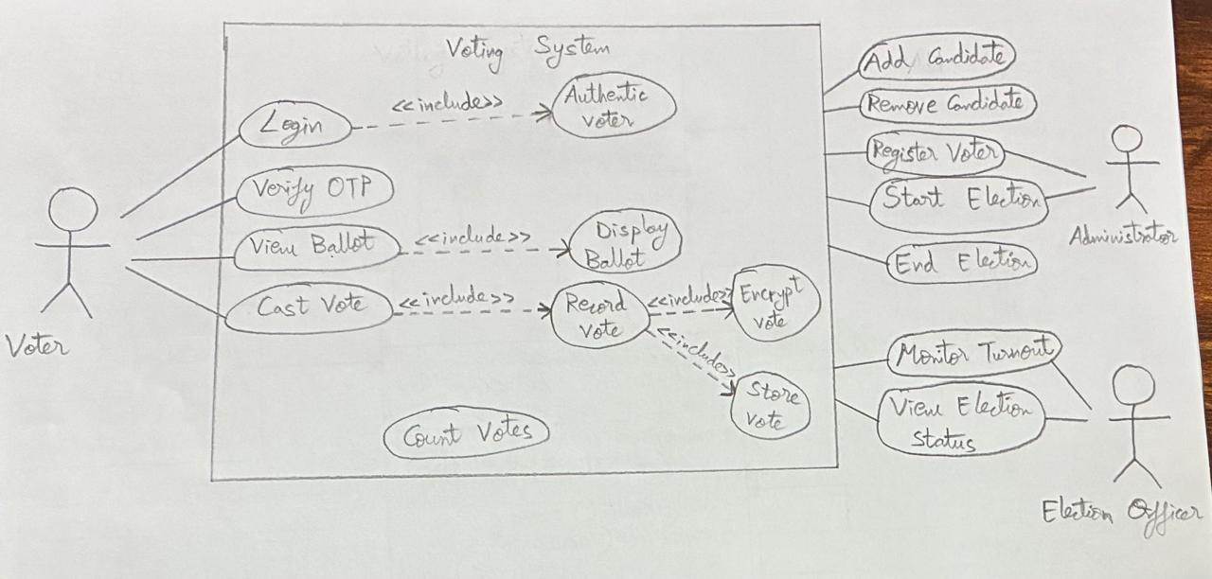

- Sequence diagram (use UML notations)
  - Choose key use cases and draw their sequence diagram. First describe the scenario in few sentences. Then draw the sequence diagram.
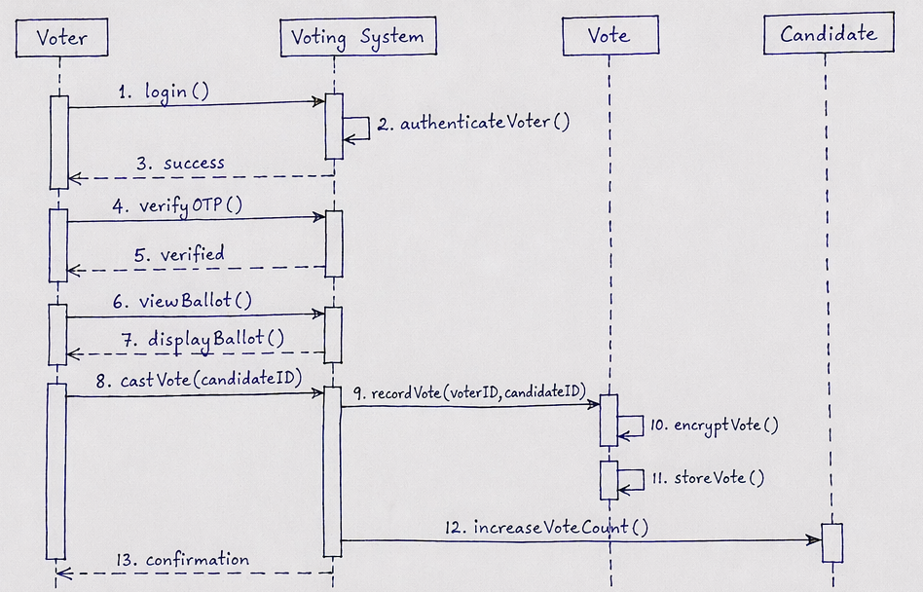
  - Choose key use cases and draw their sequence diagram. First describe the scenario in few sentences. Then draw the sequence diagram.
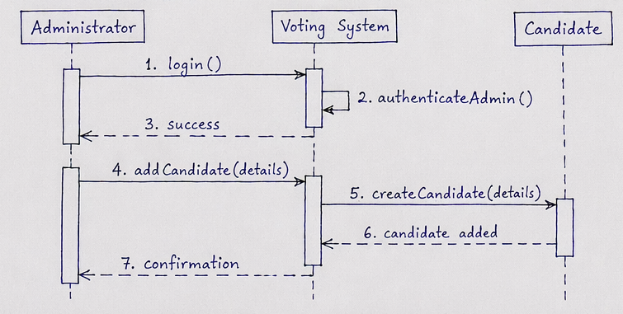

____________________________X___________________________

